NAAN MUTHALVAN PROJECT

COLLEGE NAME : ALAGAPPA ARTS GOVT COLLEGE

PLACE : KARAIKUDI

DEPARTMENT : B.COM

PROJECT NAME : ZOHO FASHION HEAVEN

OUR TEAM MEMBERS

1. S. JANAPRIYADHARSHINI
2. G.ILAKIYA
3. P.ISWARYA
4. N.JAYASRI

PROJECT REPORT TEMPLATE

1.Introduction

1.1 Overview

A Brief Description about your project

1.2purpose

The use of this project is what can be achieved by using this

2.Problem definition & Design thinking

2.1 Empathy Map

Paste the ideation & brainstorming map screenshot

2.2 Ideation & brainstorming map screenshot

3.Results

Final findings (output) of the project along with screenshots

4.Advantages & disadvantages

List of advantages & disadvantages of the proposed solution

5.Applications

The areas where this solution can be applied

6.Conclusion

Conclusion summarizing the entire work and findings

7.Future scope

Enhancements that can be made in the future

8.Appendix

Attach the code for the solution built

INTRODUCTION

1.1Overview

Fashion Heaven our project is about recruitment experts in contemporary and luxury fashion. Zoho books helps our project to manage sales & handle invoicing.

1.2Purpose

Our project purpose a company that specializes in fashion recruitment, executive search, consultancy, and coaching for the fashion and luxury industries & wants zoho books helps us to maintain accurate financial records and streamline their operations.

2.Problem definition & design thinking

2.1Empathy map

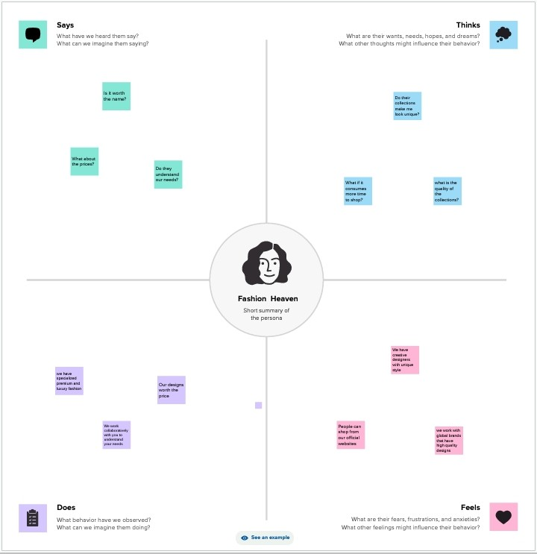

2.2Ideation & brainstorming map

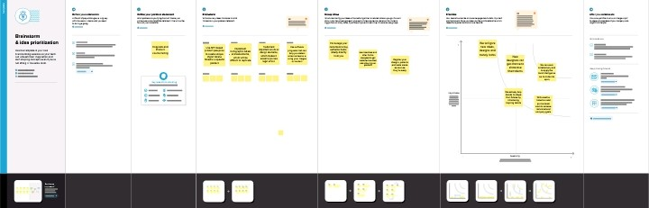

3.Results

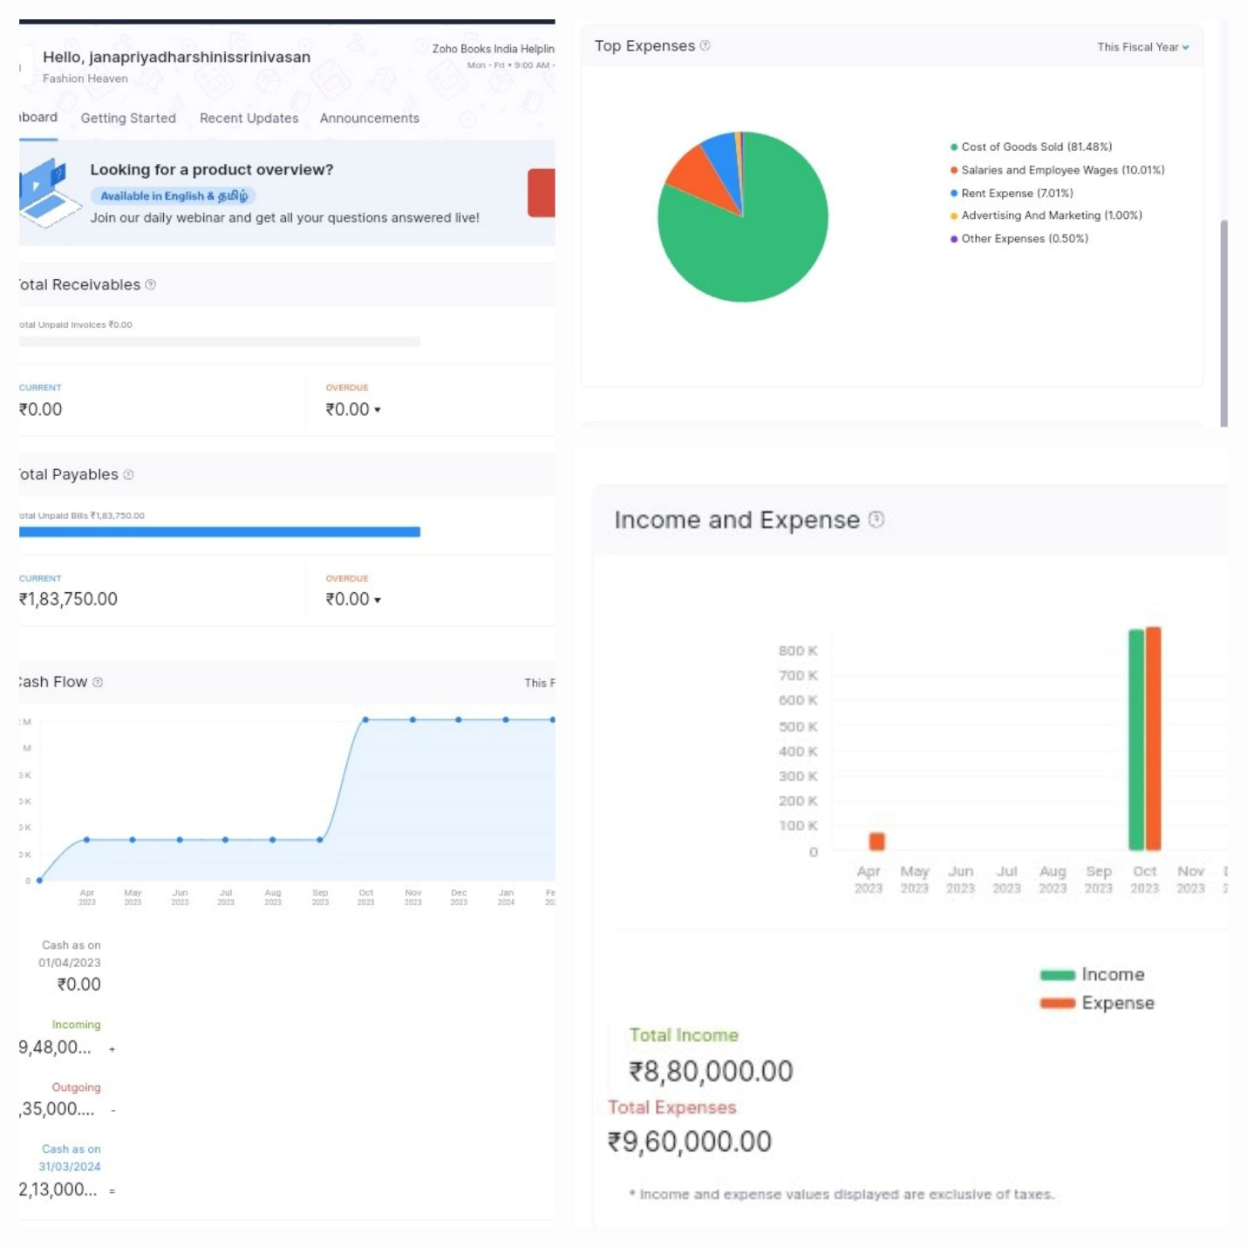

4.Advantages & disadvantages of proposed solution

ADVANTAGES

1. It seems constant Growth and innovation.
2. It generates professional invoices for our clients.
3. It helps to satisfy the needs and wants of our clients.
4. It utilizes zoho books to maintain sales, track inventory and handling invoice.
5. It can also attains our clients track expenses related to designs and supplies.
6. It helps us to maintain accurate financial records and streamline their design priorities.

DISADVANTAGES

1. Budget constraints
2. High rental prices, living wages and ricing fabric costs
3. It demands long hours to netwok, market and design
4. In initial stages you have to work longer hours
5. High staff turnover rate
6. Fashion stores have to follow fashion trends

5.Applications

1. The areas were this solution can be applied is online marketing.

2.The people can use their android mobile and they use the apps and they order their clothes.

3.And also by using social media the people can see the other interviews and videos of our designs by someone they can also prefer the taste of designs.

4.They are also influenced by them and order the clothes in online marketing.

5.Many fashion businesses are looking at smart effective.

6.Conclusion

Our Fashion Heaven conclusion is from our point of view that we specialize in freelance, consultancy and permanent roles from entry-level to CEO across Design, Brand Management, Buying, Business Development, Client Management, Digital Marketing & Communications, Styling. In supporting positive evolution, we partner with starting up, emerging and established business including ethical and sustainable brands.